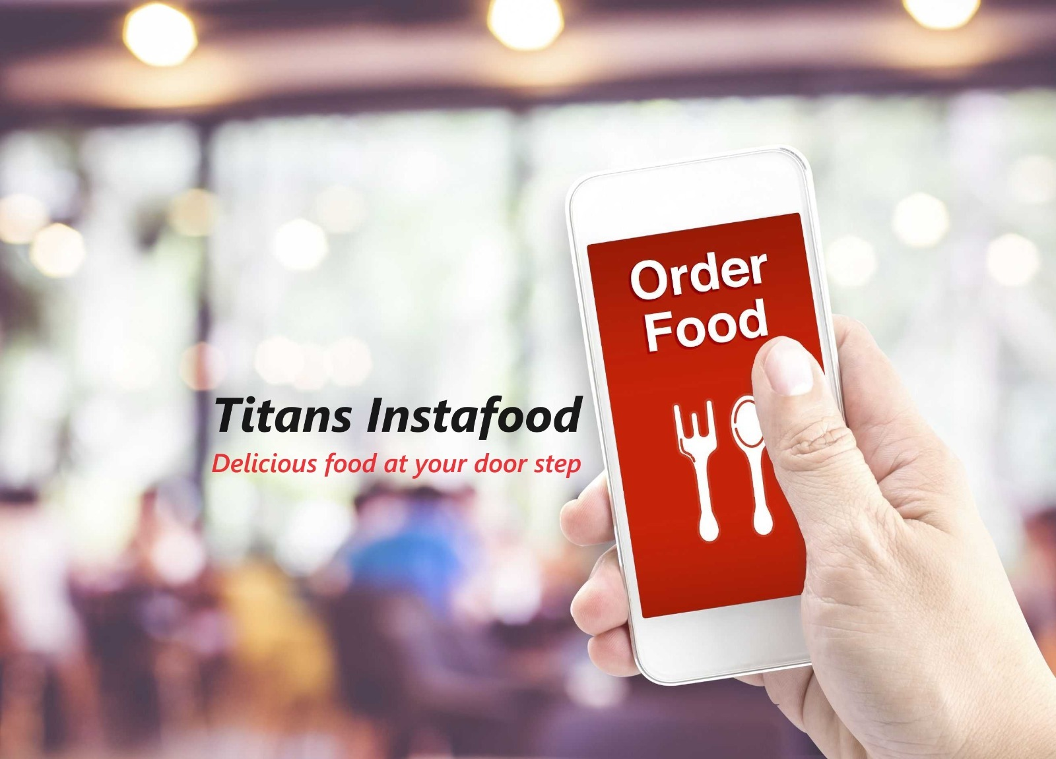

**System Proposal**

|  |  |
| --- | --- |
| **Project Name** | Food Ordering System |
| **Project Sponsor** | Dr. Jeff Tirschman, PMP (Director of Sales & Marketing) |
| **Organization Name** | Titans Food |
| **Contact Information** | +19145545112 / [titanfood@towson.edu](mailto:titanfood@towson.edu) |
| **Organization Approval** | Dr. Chris Brown |
| **Priority** | High |
| **Proposal Date** | 02/22/2024 |
| **Contactors** | CIEM IT CONSULT |
| **Consultants** | EugeniaQuarcoo, Christopher Sebina, Sunday Oyebiyi & Itunuade Jagun |

**System Proposal**

**System Analysis/Justifications**

|  |  |
| --- | --- |
| **Business Need** |  |
| Titans Food has established a reputation for its distinct culinary flavors throughout the city for more than two decades. However, the traditional ordering process employed by Titans Food has resulted in longer queues, higher administrative expenses, subpar customer service, and a lack of accountability. The situation worsened during the COVID pandemic when Titan's business had to cease operations entirely, while its competitors capitalized on food ordering systems. To tackle the previously mentioned challenges and secure a competitive edge, Titans Food needs to adopt a modern and streamlined food ordering system. This strategic move is expected to enhance customer service, boost sales and revenue, minimize direct customer contact, reduce operational costs, and facilitate data storage for future planning and projections. |  |
|  |
|  |
|  |
|  |
|  |
|  |
|  |
| **Functionality** |  |
| The Food Ordering System will offer a comprehensive set of features to meet the needs of both customers and Titan Food restaurant. Key functionalities include:  **An intuitive platform accessible via web and mobile applications for easy navigation: Functionalities for customers:**  **User-friendly Interface:**  Customers will use this user-friendly interface to navigate menus, select items, and place orders without any difficulty.  **Menu Exploration:**  The platform will present a well-organized menu with clear categories, descriptions, and images to assist customers in making informed decisions.  **Order Placement:**  Customers should be able to select between delivery, pickup, or dine-in options based on their preferences.  **User Accounts and Profiles:**  Customers should be able to create and manage their profiles, view order history, and save favorite items for easier reordering.  **Order Payment:**  Integration with secure payment gateways for online transactions, including credit/debit cards, digital wallets, and potentially cash on delivery for customers.  **Customer support:**  Customers will have access to responsive customer support channels (such as live chat, email, or phone) to promptly address any concerns or inquiries.  **Delivery Tracking:**  The system will let customers track their orders in real-time to keep them updated on their progress, from preparation to delivery.    **Functionalities for Restaurant:**  **Order management:**  The restaurant will have a streamlined system for managing incoming orders, including notifications, order prioritization, and order history.  **Order line:**  The restaurant will have the flexibility to set their own delivery radius, minimum order amounts, and operating hours according to their preferences.  **Promotional Discounts Campaigns Offers:**  The capability to create and manage promotional campaigns, discount codes, and special offers helps attract customers and boost sales.  **Real time Menu update:**  Titan restaurant will be able to easily update menus, add new items, and adjust prices through a user-friendly interface.  **Secure payment Processing:**  The system will provide Titans, seamless integration with point-of-sale (POS) systems to ensure streamlined payment processing and order synchronization.  **The system will include a dashboard to accept and process orders. store data to analyze sales quantity, revenue, and customer satisfaction:**  The restaurant will have access to analytic and reporting tools which enable tracking of sales, monitoring performance metrics, and gaining insights into customer preferences.  **Special Offers and Discounts:**  Availability of promotional deals, discounts, and loyalty programs to encourage repeat business.  **Performance Monitoring:**  Monitoring tools are available to track order fulfillment times, staff performance, and customer satisfaction metrics.  **Personalized Orders:**  Customers have the option to customize their orders based on their preferences, whether it is choosing toppings, sauces, or portion sizes.  **Feedback and Ratings:**  Capability for customers to provide feedback, ratings, and reviews on food quality, delivery speed, and overall experience.  **Compliance and Regulations:**  Ensuring compliance with local food safety regulations, data privacy laws, and industry standards is essential to maintain trust and integrity. |  |
|  |
|  |
|  |
|  |
|  |
| **Tangible Benefits** |  |
| Titans Food System will reduce operation costs by 35%. Titans Annual Operation Cost for 2023 was $20,000, with use of this system, potential operational cost savings will be $7,000 per year. Increase sales through customer satisfaction. Based on the previous annual sales realized by Titans, which were $60,000, the anticipated 10% increase in sales will give an additional sales value of $ 6,000 through customer satisfaction. Highlighting an increase in revenue of 40% means that Titan’s previous year's revenue of 40,000 will increase by an additional amount of $16,000 (40% of $40,000 added to Year 1 revenue) and subsequent yearly growth of 40%. Year 3 Revenue: $78,400 (40% of $56,000 added to Year 2 revenue) Year 4 Revenue: $109,760 (40% of $78,400 added to Year 3 revenue. Also, the system will assist in analyzing data for business growth. The system will incorporate an implementation of Data Analysis Tools: $1,000 (one-time cost). This will improve efficiency and strategic decision-making. The Titan food system will create easy access to the store through an ordering system, The system will create excellent user experience. Which will lead to an increased Customer Satisfaction, Improved ratings, positive reviews that will increase customer retention by 15%. Increase sales quantity by 50% by leveraging system promotional features. |  |
|  |
|  |
|  |
|  |
|  |
| **Intangible Benefits** |  |
| The use of the food ordering system would improve the brand image, fostering positive word-of-mouth marketing for the restaurant and reducing staff stress. |  |
|  |
| **Special Issues / Constraints** |  |
| This project will be completed by 28 Jun 2024 (Four Months). We anticipate potential challenges in integrating diverse technologies and engaging network providers. Continuous monitoring and updates will be crucial to address any unforeseen technical issues. Having ample time to ensure robust data security measures are in place to protect user information and facilitate secure payment transactions is key. The system will be available 24 hours/day for customers to order food anytime ahead. |  |
|  |
|  |
|  |
|  |
|  |
|  |
| **Other Information** |  |
| A detailed budget breakdown is provided in the accompanying cost benefit sheet, outlining the costs associated with development, testing, and ongoing maintenance. A comprehensive training plan for restaurant staff will be implemented to ensure a smooth transition to the new system. |  |
|  |
|  |